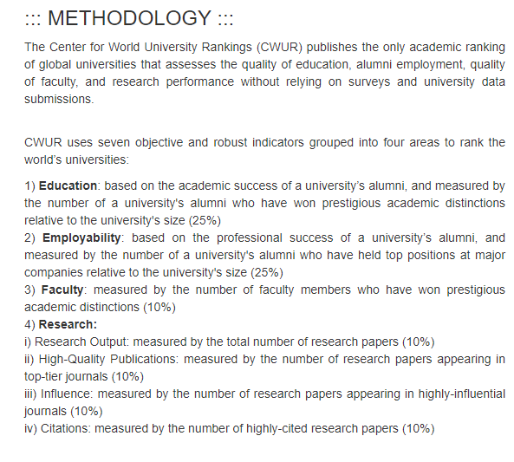

Merge data from <https://cwur.org/2016.php> where I will add the 2016-2022 data on all schools (or possibly just McMaster University)

* Need to update the 2012 and 2013 data to include top 1000 ( currently only includes the top 100). 2014, 2015 includes the top 1000 schools.